# Tower of Hanoi

1. Domain driven diagram -

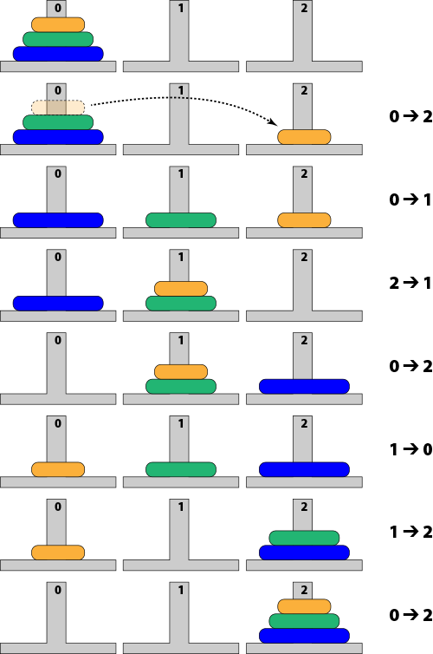

1. Project Solution-

